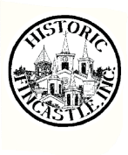
Name: ___________________________________________________
Address: _________________________________________________
__________________________________________________
Email: ____________________________________________________
____________________________________________________
Phone Number /Cell Number: _______________________________
Returning Member _______ or New Member _______
HFI is a 501(c) non-profit organization and all contributions including membership are tax deductible. Make checks payable to
HISTORIC FINCASTLE, INC; P.O. Box 19, Fincastle, VA 24090 Please check membership type and donation amount.
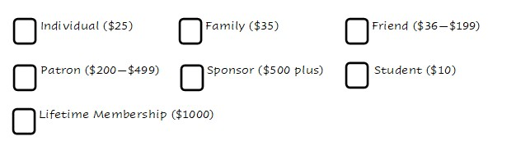

Greetings to “History Buffs” and “Preservation Enthusiasts”,
Historic Fincastle, Inc. (HFI) was incorporated in 1968 as a non-profit organization devoted to protecting and preserving the historic town of Fincastle, Virginia. Its parent organization, The Council for the Beautification and Preservation of Fincastle, was formed in 1967. HFI has contributed thousands of dollars and volunteer hours towards fulfilling its mission for the last 55 years. This can only be done with many volunteers and volunteer hours. The Executive Committee and The Board of Directors (BOD) will be working to help provide opportunities for you to donate your wisdom, your talent and your time to make sure we continue protecting and preserving this historic town that is now 252 years alive. We will be looking for individuals who want to serve on a committee or chair a committee with a member of the Board of Directors to help plan a program that celebrates our town. Please consider the opportunities below and help out as you can. Help us preserve, protect and promote Historic Fincastle.
Thank you,
The Executive Committee
President, Patsy Dickerson
Vice-President, David Lloyd
Secretary, Meredith Bowman-Shelton
Treasurer, Yvonne Saunders
Please check areas or events in which you would be interested in volunteering. You do not need to be on the Board of Directors to volunteer, nor do you need to attend the BOD meetings.

______ Landscaping and maintenance of HFI properties (Early Cabin and Wysong properties)

______”Step Back into History” full day of historic tours and open buildings (in May 2024)

______ Fincastle Fall Festival (4th Saturday in September): ____publicity ___day of event
___planning ___as needed

______ Holiday Home Tour and Market Place: ______ open your house _______serve as a docent (2nd Saturday in December) _______help at the Marketplace

______ HFI Scholarship Program for LBHS and JRHS (April/May)

______ Helping decorate and undecorate the Tinsel Tree (end of November/first part of December)
______ Souvenir Coordinator

______ Manage the Instagram and Facebook posts

______ Manage the creation of QR codes and signage around the town for visitor to learn the history of the area

We are also looking for new ideas. New IDEAS and/or COMMENTS? _______________________________
_______________________________________________________________________________________

