HIstoric Fincastle, Inc

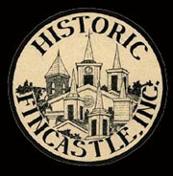

April 2011

Descendents of James Matten Early Visit Fincastle

Town and cabin shown to Ohio visitors

“We had a great time! Thanks for everything.” James (Jim) R. Early, Mary Jo Early, son, Erik Early, and Brandon Gaunt, soccer teammate, all from Dublin Ohio.

”My wife and I were talking on the drive to Williamsburg that we wanted to contribute to the Historical Society in some way. The next day I showed my two sisters and they were amazed. I think the kids thought it was pretty neat but they don’t show much emotion at this age. It’s amazing to think what it must have been like 210+ years ago without; electricity, plumbing, clean water on demand, heat and AC! "

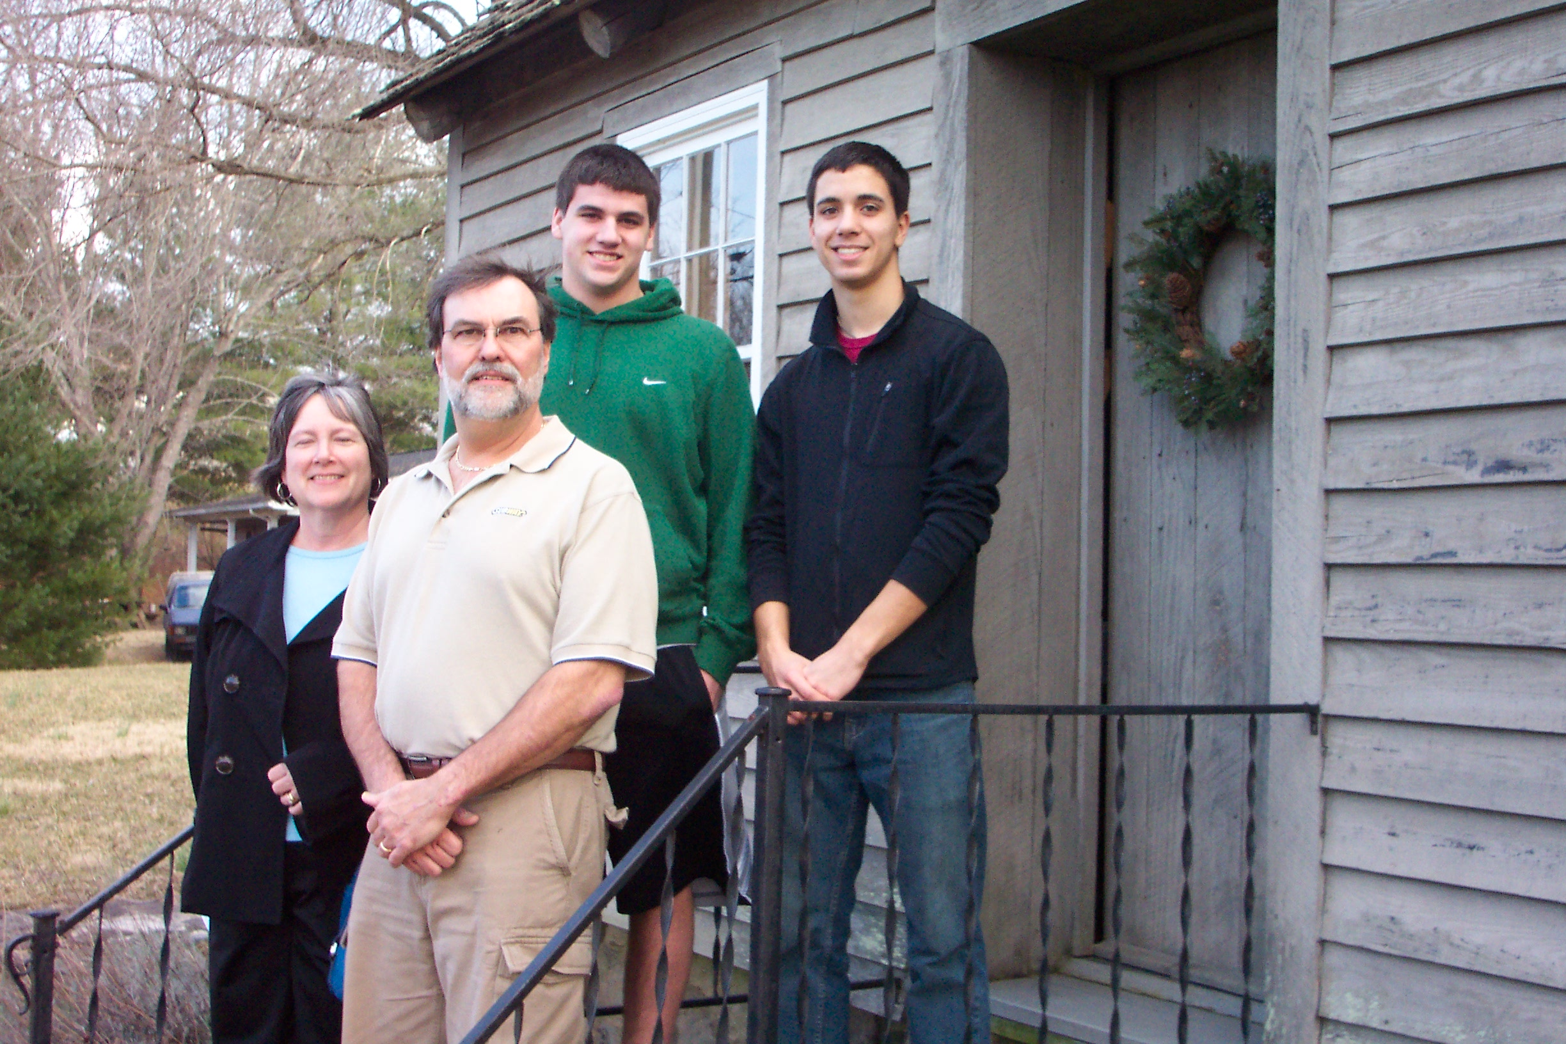

**Historic Fincastle, Inc. Honors Memory of Harry and Dottie Kessler with plaque**

As part of the HFI annual open house in December of 2010, Paige Ware spoke about and unveiled a memorial plaque in honor of longtime HFI members and Fincastle residents, Dorothy (Dottie) and Harry Kessler. Many local residents made contributions to a memorial fund upon Dottie death in February, 2009 and those funds were used purchase a historical-type plaque for the James Matten Early Cabin. Harry and Dottie Simmons Kessler were both raised in Fincastle and they loved the town and worked tirelessly to preserve its historic buildings, improve the services of the town, and educate all about the town’s history.

Dottie was a founding member of HFI in 1969 and served for thirty years as a member, on the Board of Directors, and as president. Dottie was an historian and for over 20 years, helped many families research their genealogy through the Botetourt Clerk’s Office and Fincastle Library. She also took the lead in getting the book, *Around Town: a Pictorial History of Fincastle*, produced and published. Dottie delighted tour audiences with interesting facts about early American life in Fincastle and at the James Matten Early Cabin, which she helped restore, furnish, and maintain. In addition to HFI, Dottie was a member of Fincastle St. Mark’s Episcopal Church, Botetourt County DAR, and Big Spring Garden Club. A Dottie Kessler quote: “You want to know your roots, where your family has been and where you are going. It gives you a foundation”.

Harry served as mayor of the Town of Fincastle for eight years and was instrumental in planning and installation of the town’s water and sewer system. Dottie and Harry are an inspiration for all of us to love this town and the surrounding area and to support preservation of his history and buildings. On behalf of the Kesslers, Tony and Karen Kessler accepted the plaque in memory of their parents.

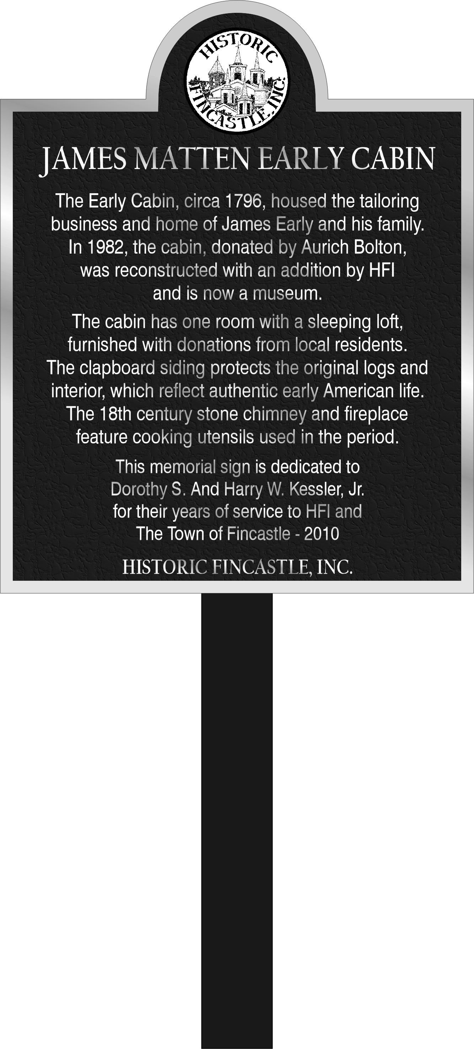

|  |
| --- |
| **Historic Fincastle, Inc.**  **Feature Publication** |
| **Around Town – Old Fincastle**  Hardbound book 96 pages  Around Town: A Pictorial Review of Old Fincastle, Virginia is a lovely hardbound book developed and published in 1990 and reprinted in 2009. It is sometimes referred to as the history "Bible" of Fincastle that was made possible through the hard work of eight HFI volunteers, who wrote it, marketed it, and participated in a book signing of reprinted copies. All second print copies purchased ($32.00 including tax + $5.00 shipping) will have an original jacket cover from the first printing, a historic element in its own right. To order a copy, call HFI at 540-473-3077 and leave a detailed message. |

**Dottie Kessler Archives & Historic Document Collection**

HFI has a very active Archives Committee who are investigating digital methods of cataloging, indexing, and incorporating scanned images into a virtual collection. Committee members visited the Historical Society of Western Virginia and viewed PastPerfect, a comprehensive software package which is the standard for the management of museum collections and is used by over 7500 organizations throughout the world.  A powerful computer, a high grade extra-large flatbed scanner, and storage media would be equipment needs.  Also mentioned were a digital camera and a camera stand.    
  
The committee will be investigating other ways of cataloging, indexing, and incorporating scanned images into a virtual collection, but Past Perfect accomplishes these and many other tasks with ease.  Because it is the standard in the museum world it also offers the potential for linkage with other users, making it a doubly desirable solution. If any HFI member or friend would like to volunteer for this committee, please contact committee chair, Gretchen Greiner, or leave a message at 473-3077.

James Matten Early Cabin Roof Replacement

Committee Plans Roof Replacement

Kip Burton, Alan Brenner, Brian Jones, Ron Lucas, & Mitch Bowman

The Property and Grounds Committee have plans to remove, repair, and replace the cedar shake roof on the James Matten Early Cabin this year. The project will be a joint venture between paid and volunteer crew members. The roof will require 18 squares of shakes, covering 1800 square feet of roof. Additional sprucing up of the interior of the cabin will also be done including interior painting.

**Corporate Donors Help Finance Early Cabin Roof Replacement**

**with Donations**   
   
*Vic Coffey, Remax All Stars  
John "Bob" Patterson  
Don Wetherington  
Piedmont Foundry Supply, Inc.  
Virginia Forge Company  
Fields Construction, Inc.  
The Bank of Fincastle  
The Glebe   
Bill Campbell  
Carris Reels, Inc*

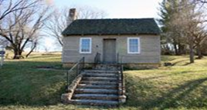

**THANK YOU!!**

**2011 Members & Friends**

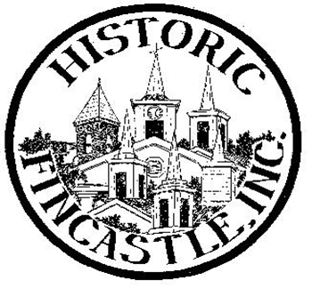

**Membership Acknowledgement**

Dear Friends and Members who have joined HFI:         
  
Your contribution will help HFI to carry out its mission to support the preservation of the historic, physical, cultural and natural resources of Fincastle and its surroundings.   
  
As a non-profit organization, HFI relies on membership contributions, corporate support and fundraising events to meet its annual objectives. Your membership contribution is sincerely appreciated.

**Thank you very much for your continuing support of HFI**

**Scholarship awarded to local high school students**

The Elizabeth and Israel Christian Scholarship is offered annually by Historic Fincastle, Inc. as a way to commemorate the history of Fincastle and encourage and support high school students who have an interest in history and are planning to pursue post-secondary education. This year’s winners:

* Mallory White from Lord Botetourt is planning to attend Virginia Tech.  In her essay she wrote of the battle of Yorktown, her admiration for General George Washington and of his importance to Virginia.  She concluded her paper saying, "I believe it was the beginning of the wonderful United States of America, the place where anyone can realize his or her dreams if the person just has the diligence to work hard enough and persevere".

* Shannon Kessler from James River is planning to attend Virginia Tech. She is interested in Meriwether Lewis and of his Virginia heritage and his Fincastle connection.  She would have liked to know "what motivated him to volunteer for such a big mission, how he was able to get so close to such an influential figure (the President), and if he always tried to remember his roots."  She also finished her essay by saying, "the Lewis and Clark expedition....managed to make an immeasurable impact on the future of an entire country…".

Fincastle History Trivia: Did you know?

Although Fincastle was formally established and incorporated in 1772 by an act of the General Assembly of Virginia, in 1794 the General Assembly passed an act changing the name to "Monroe."  Then in 1797 a petition was sent to the General Assembly to change the name back to Fincastle.

("Historic Fincastle 1772": Timeline contributed to book by Dottie Kessler)

|  |  |
| --- | --- |
| **Inside This Issue** | |
|  | **2011 Membership** | |
|  | **History Trivia**  **Archives & Historic Document Collection** | |
|  | **Santillane: Fincastle Connection**  **Scholarship Winner** | |
|  |  | |
|  |  | |
|  |  | |

***Board of Directors***

***Carol S. Brenner***

***& Marni Jones***

***Co-Presidents***

***Lissy Merenda,***

***Secretary***

***Missy Sirgurdson,***

***Treasurer***

***Board Members***

***Lynne Bolton***

***Mitch Bowman***

***Lyn Burton***

***Gretchen Greiner***

***Marcia Neighbors***

***Shirley Sydnor***

***SAVE THE DATE:***

**2011 Holiday Home Tour & Marketplace 10:00 – 4:00**

**Eight Local Homes open for Tour**

**Fincastle and Surrounding Area**

**December 10, 2011**



**2011 HFI Memberships Received through April 1, 2011**

|  |  |  |
| --- | --- | --- |
| **Individual Members** | **Family Members** | **Friends** |
| |  |  | | --- | --- | | Michele | Alexander | | Joe | Camper | | Faye | Caldwell | | Melville | Carico | | Brenda F. | Chapman | | Gene | Crotty | | Virginia | Fodge | | Rose Ellen | Gravett | | Deborah | Hedrick | | Patricia A.  Joseph | Honts  Johnson | | Dorothy | Langford | | Geneva | Mateer | | Frank Taylor | Miller | | Lew | Moore | | Robert  Martha | Murray  Murray | | Betty | Newman | | Nancy M. | Pauley | | Mrs. Billy W. | Proffitt | | James | Rickman | | Beverly | Stafford | | Margaret R. | Webb |   Patron Members   |  |  | | --- | --- | | Dr. Henry | Bowen | | James E. | Hickenbotham | | Karen & Henry | Hicks | | Bob & Reedie | Waid | | Samuel | Wysong |   Lifetime Members   |  |  | | --- | --- | | Sarah & Pardee | Early | | Anita & James | Firebaugh | | Chuck & Carole | Geiger | | Sandy | Stokes | |  |  | |  |  | | |  |  | | --- | --- | | Evelyn Myers | Besley | | John & Patricia | Brown | | Neil & Heather | Brush | | Bill & Rhonda | Campbell | | Scott & Susan | Critzer | | Stan & Connie | Diez | | Dudley & Martha | Emick | | Mike & Cathy | Goad | | Katie, Maggie, Anne & Eva | Grumbine | | Lee & Magae | Hartzell | | Jim & Marsha | Helms | | Sidney & Tommy | Hunter | | Brian & Marni | Jones | | Garland & Jane | Jones | | Gary & Dreama | Kattenbraker | | Barbara&Alvin | Kagey | | Ed & Ruth | Korth | | Jim & Wilma | Lambert | | Mr. & Mrs.  Joseph D. | Logan | | Betty & Mack | Luber/Bullard | | Pete & Bette | Mahony | | Dan & Lissy | Merenda | | Lee & Luther | Minnix | | David & Trish | Morris | | Joella & Stewart | Morris | | Mack & Marcia | Neighbors | | Stan & Carolyn | Nelson | | Beth & Steve | Pappas | | Don & Judy | Race | | Erik & Ruth A. | Schwendeman | | Jack & Betty | Spigle | | Josh & Lori | Taube | | Mr. & Mrs. E.C. | Westerman | | Pete & Freda | Wood | |  |  | |  |  | |  |  | |  |  | | |  |  | | --- | --- | | Samuel & Judy | Aman | | Robert & Sue | Bagnoli | | Stephen | Bailey | | Dr. & Mrs. Max | Bertholf | | David & Alison | Bondurant | | Hix & Lillion | Bondurant | | Mitch & Bobbi | Bowman | | Carol & Alan | Brenner | | Kip & Lyn | Burton | | Lynn & Raul | Cuervo | | Peggy C. | Davis | | Lee & Gretchen | Greiner | | John & Genevieve | Goss | | Betty B. | Hawes | | Robert H. | Hoffman | | Robert & Helen | Holt | | Charlotte & Dan | Jones | | Julia & Michael | Klapproth | | Allen & Ann | Layman | | Helen M | Morris | | Edith Mayhew | Moses | | Allen & Patricia | Nelms | | Pat | Simmons | | Kathleen & Michael | Sloan | | Dr.& Mrs. W. Graham | Stephens | | Eleanor McDowell | Thompson | | John & Linda | Thornton | | Paul & Terry | Tucker | | Scott & Barbara | VanCleef | | Patty & Rick | Vari | | Donald & Ulla | Wetherington | | Pam & Ralph | Wiegandt | | H. Douglas & Trish | Wilhelm | | C. Locke | Wysong | | Mary | Wysong | | Peg & Jerry | Wysong | |
| **It’s not too late to join for 2011! Membership form on page 5.** |  | **Thank you for your support of HFI** |

**Focus on HFI Volunteer: Kip Burton**

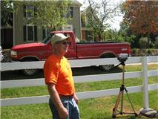

Many HFI volunteers and members complete tasks regularly to assist in the mission of the organization. HFI would like to recognize Kip Burton for his countless hours of bookkeeping, tree trimming, facilities maintenance, coordination of music, and more. We thank Kip for his cheerful willingness to be a HFI volunteer! **Milton Hall, Santillane and Santillane Farm:**

**The Fincastle Connection**



by Lissy Merenda

At the funeral of local matriarch, Dottie Kessler, I met an historian who seemed to be extremely knowledgeable regarding the history in our area. Our area being the Blue Ridge and Allegany Mountains in particular. I proceeded to listen politely but was soon consumed by the breadth of information he was sharing, and was relieved when he told me he would send me a few articles about it all. In a few weeks I received a plethora of articles from Howard R. Hammond of Greenville, SC. I scanned them quickly and was fascinated by what they revealed. I volunteered to write a brief article for the Historic Fincastle newsletter. Today, I re-read them at length and was grateful to this gentleman and his appreciation for Dottie Kessler’s heritage. There is no way I can begin to capture the ways these three historic landmarks are inextricable interwoven with each other and the lives of the people who graced them. Since there is no way in the space provided to do justice to this history, I would like to offer some major highlights and make sure, until Dottie Kessler’s chronology is archived, that copies of these articles are made available in the Botetourt Museum of History.

* Milton Hall a Victorian Gothic mansion was erected in 1872 by a titled English family, Lord and Lady Milton. Viscountess Milton purchased the tract at the site of Old Callaghan Tavern in 1871. (See photo page 7)
* The tavern was erected in Bath County in 1792 by Dennis Callagham, a revolutionary war veteran and Irish expatriate.
* The Tavern was the last mail stagecoach stop (Bluegrass Trail, now old RT 60) travelers journeyed on before crossing over the Allegany Mountains.
* Also accompanying the Miltons from England was Lord Milton’s personal physician, Dr. Thomas Miller and his family.
* The Miltons stayed at Milton Hall for just three years. Due to Lord Milton’s poor health, they returned to England, while Dr. Miller and his family remained.
* Another large tract of land of 493 acres was the site the other grand estate built in the Colonial Federal style by George Hancock in 1795. It later came to be called Santillane (a fictional name given by Dr. Miller’s wife).
* Hancock’s daughter, Judith, married explorer, William Clark. In the marriage bond, a note at the bottom of the permission invites Colonel H. Bowyer, Clerk of the Court, to Hancock’s home for the evening, perhaps indicating William and Judith were married Tuesday, January 5, 1808.

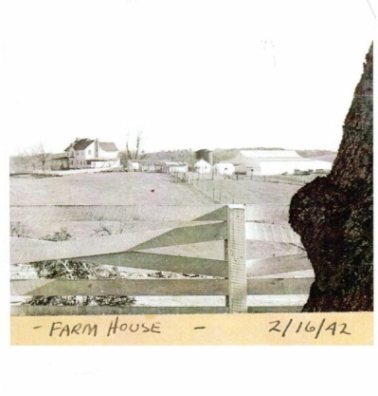

* Santillane was later purchased by a prominent family from Chicago, the Bowyers.
* When the Bowyers placed the property on sale, it was purchased by Dr. Miller in 1877. He later built Santillane Lodge (now called Santillane Farm) for his son, George in 1902. Dottie Simmons Kessler and her brother William Simmons are the great-grandchildren of Dr. and Mrs. Miller. They both lived in Fincastle.
* Hugh McAllister and later his son A.A. McAllister purchased and expanded the property holdings around Milton Hall.
* Eventually it was purchased by Mary Dowdy and her husband in 1980. Mary restored and modernized it. She received both Virginia and National Historic Landmark status. It served as a B & B and extended stay option for wealthy travelers. The Dowdys divorced and ironically, Mary, now Mary Meyers, bought Santillane Lodge, bringing back the Fincastle connection.
* Even more ironic, when Dan and Phyllis (Lissy) Merenda bought Santillane five years ago, it turns out that two of their children went to school with Dottie Kessler’s grandchildren, the Prestons, in Roanoke.

So, is all this fate, serendipity or just amazing? To learn more visit the Botetourt Museum of History where the following articles will be placed:

*A Tale of Two Houses, by Frances McNutty Lewis*

*Laura’s Legacy Milton Hall Was Erected by Titled English Family by Gay Arritt*

*Lewis & Clark: the Fincastle Connection by Dorothy Simmons Kessler*

