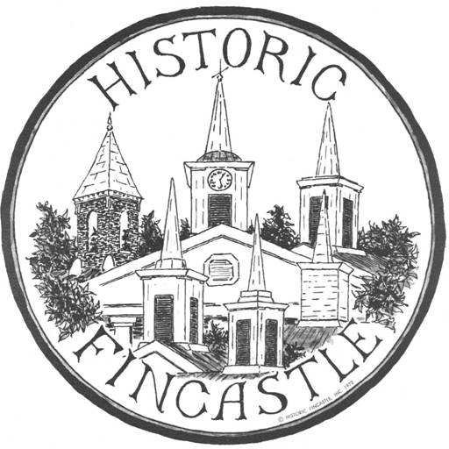

2016 HFI Holiday Home Tour & Marketplace
Saturday, December 10, 2016
The Tiny House Revolution is here!! Come tour two beautiful examples right in Fincastle, The Martin Tiny House and The Ferguson Tiny House. Other tour sites include: 25 East Main B&B, The Boarding House, Godwin Cottage, Henderson Bungalow - Referred to as Bliss Guest House, Botetourt County Courthouse, and Botetourt County History Museum.
  - Tour tickets are $15.00 per person ($12.00 for HFI members) and will be sold at the Fincastle Baptist Church, 7330 Roanoke Road (Route 220) starting at 9:30 am
  - Tour sites will be open from 10:00 AM until 4:00 PM.

The Marketplace, in the Fincastle Baptist Church building, is free and open from 9:30 AM until 3:00 PM with over 40 local and regional artists selling gift and home items.
All proceeds from this event are used to support the mission of Historic Fincastle, Inc., to support the preservation of the historical, physical and cultural resources of Fincastle, Virginia and its surroundings. SPONSOR:
